**Name: Aleena Zainab**

**Intern ID: TN/IN02/PY/005**

**Task no: Task 1**

**Question: 1**

TASK # 1

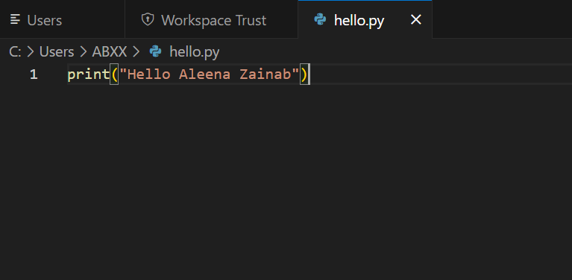

OUTPUT:

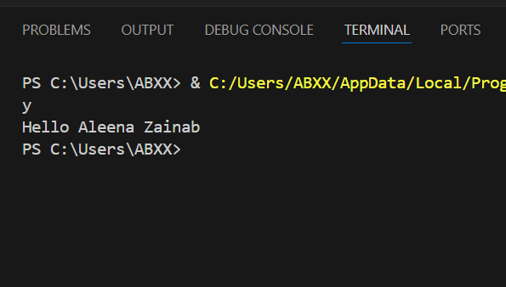

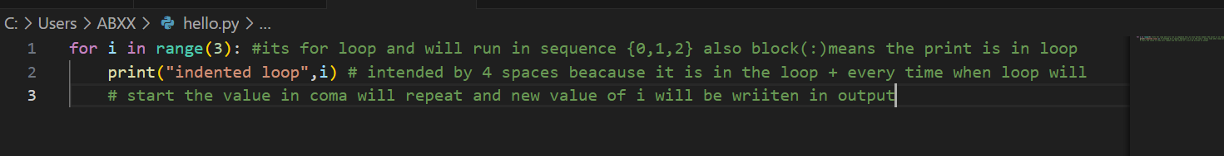Task 2:

Output:

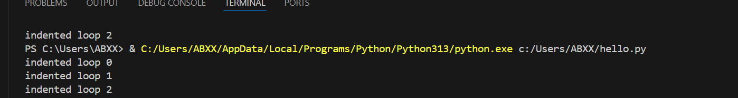

Task 3: PART 1

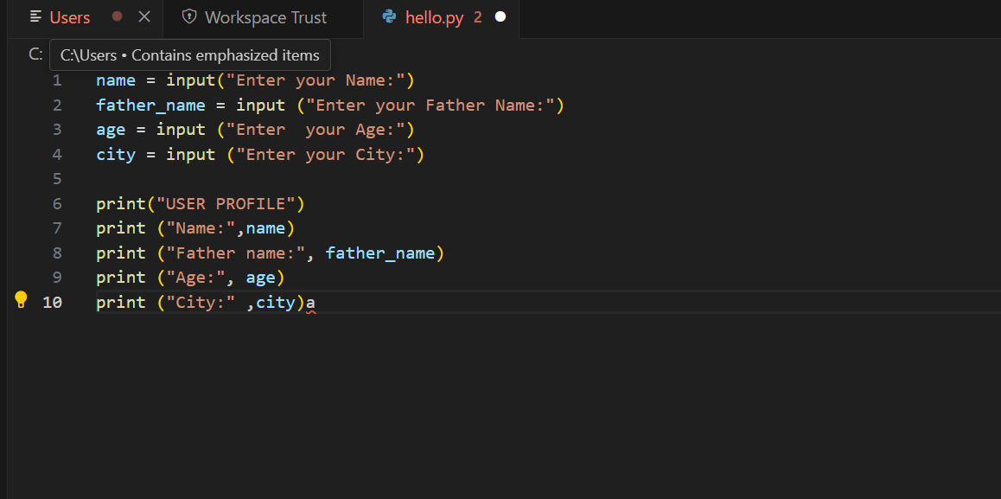

Output:

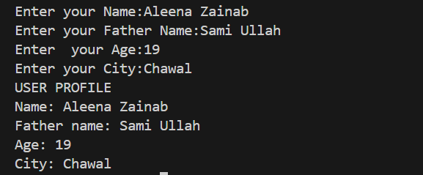

PART 2

Task 3:

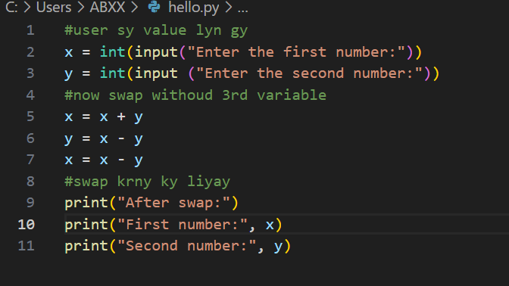

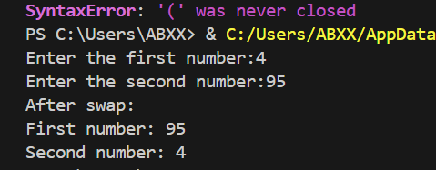Output:

Task 4:

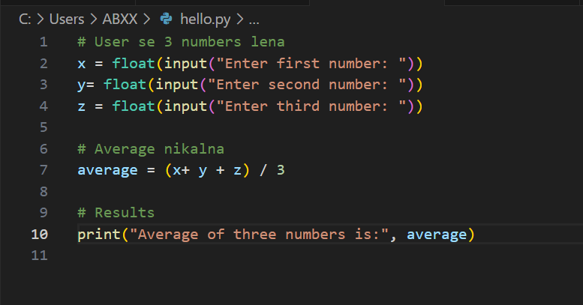 Part 1:

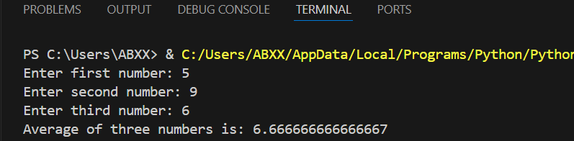Output:

Part 2:

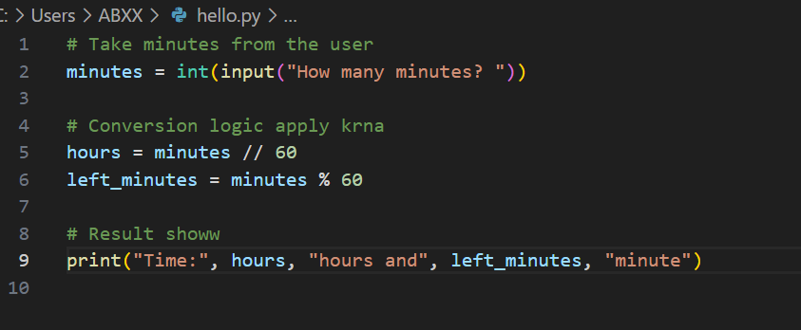

Output:

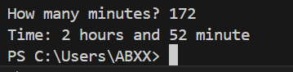

Task 5:

Part 1: BMI calculator:

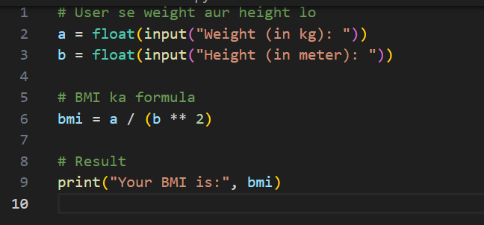

Output:

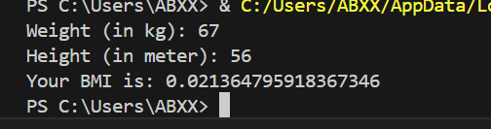

PART 2:

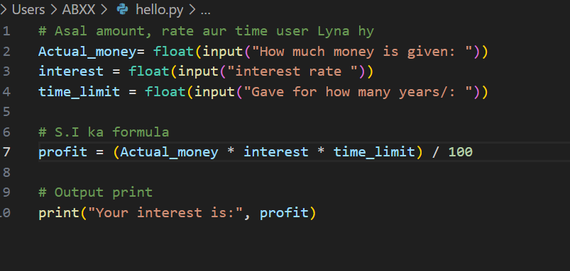

Output:

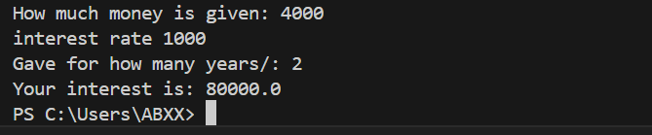

Task 6:

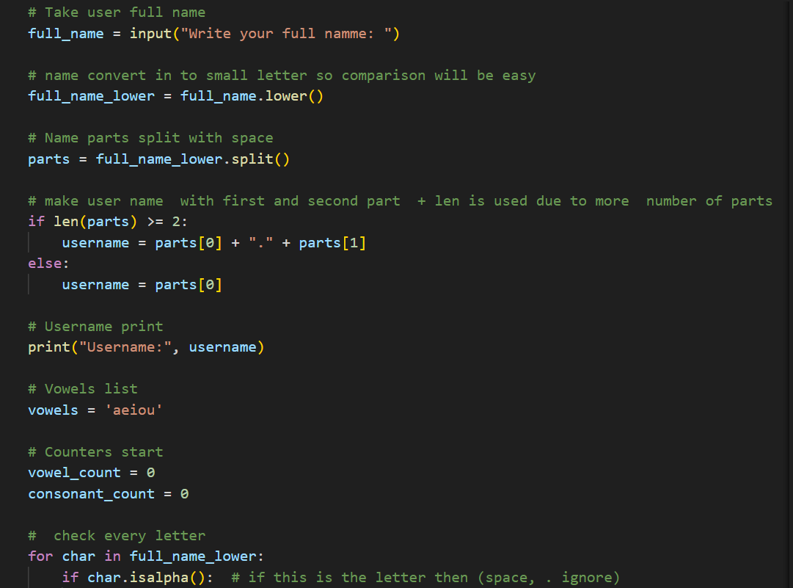

Output:

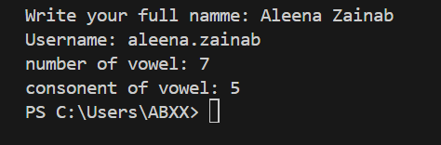

Task#7:

Part 1 : Grade Calculator

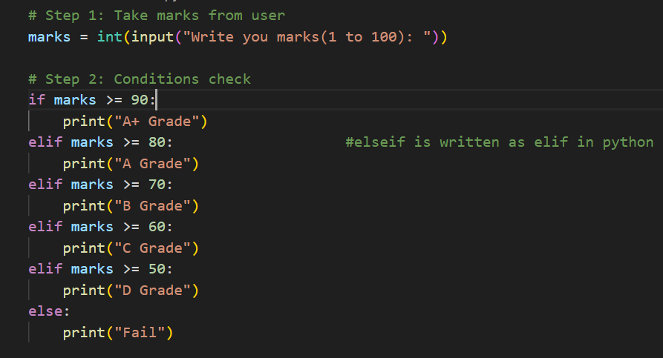

Output:

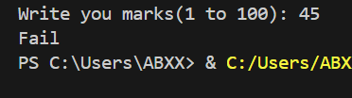

Part 2: Password strength checking

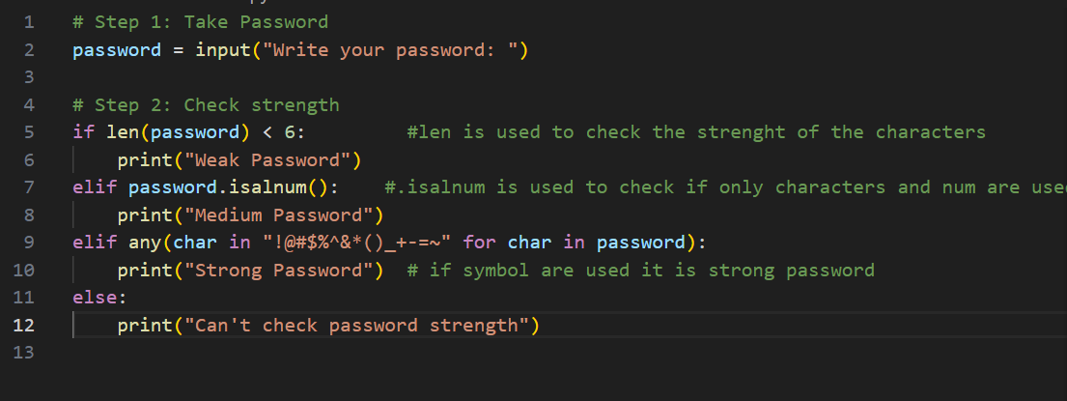

Output:

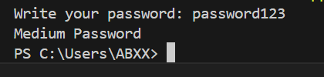

Task # 8:

Part 1: Multiplication Table:

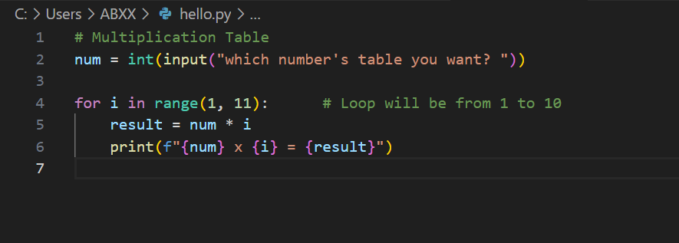

Output:

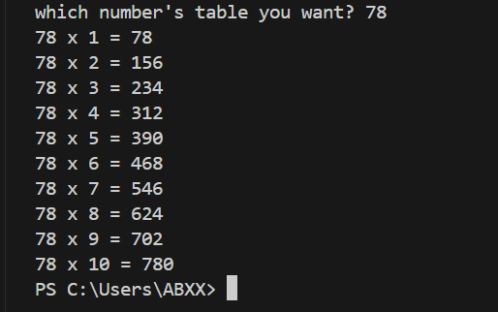

Part 2: Sum of numbers divisible by three:

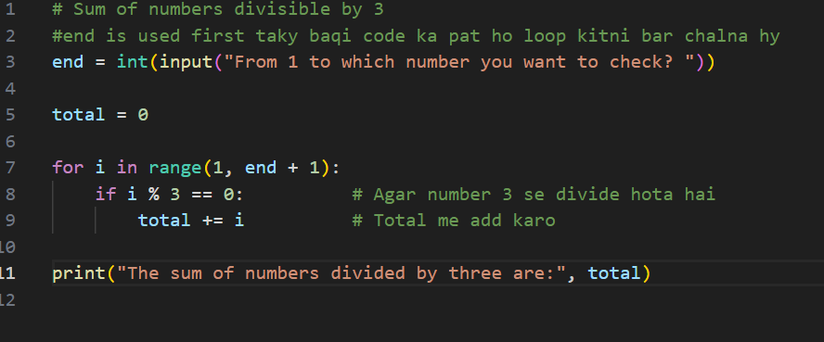

Output:

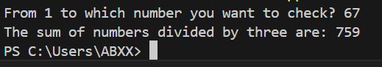

**Challenge Task**

**Code;**

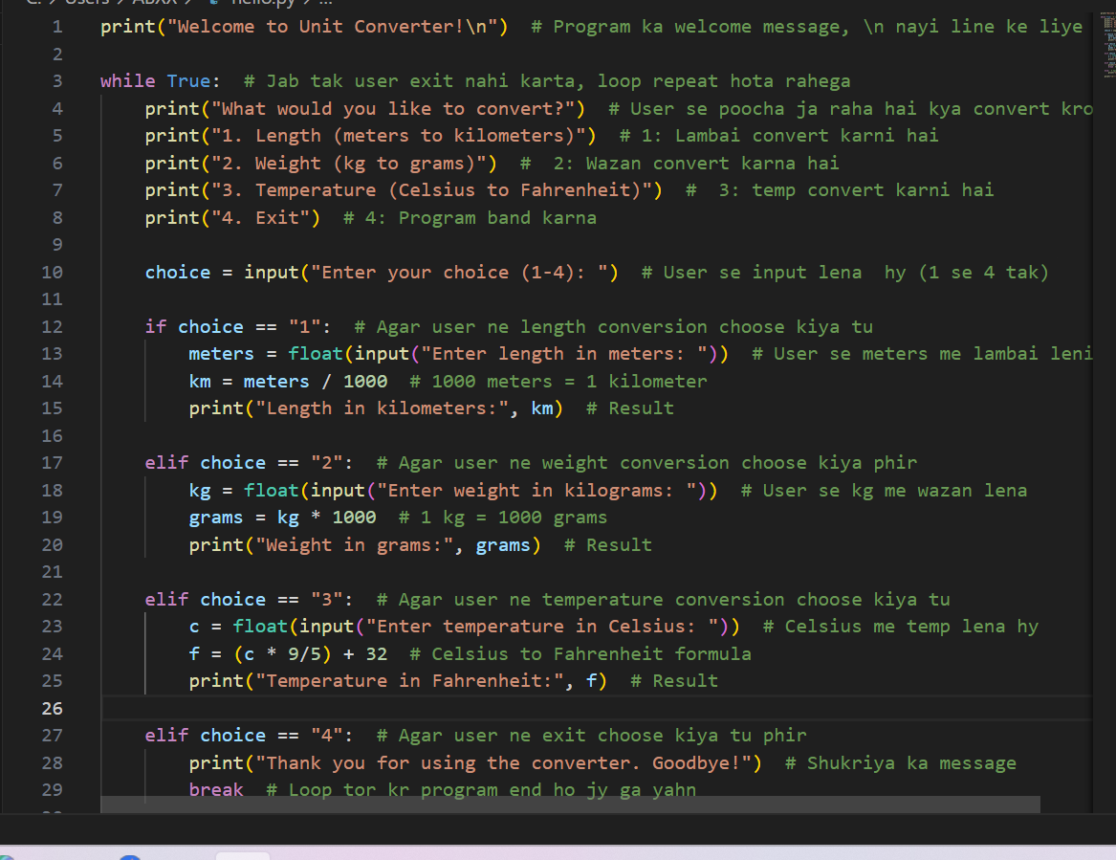

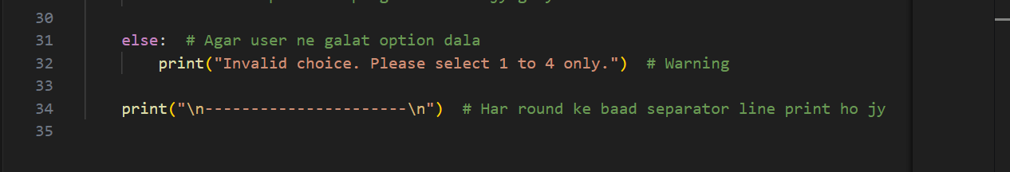

**Output:**

